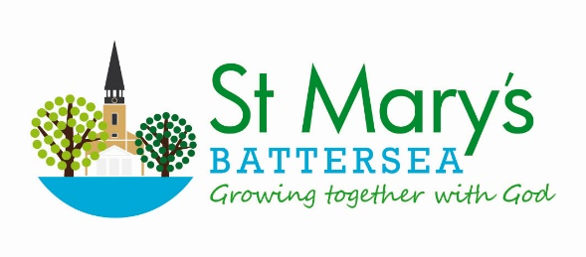
Banns of Marriage Application Form
The following questions must be answered by the wedding couple themselves.
Please complete in black ink, and in BLOCK LETTERS.

Date and Time of Wedding
The Church you wish to be married at and the Parish it is in

 |  | MAN |  | WOMAN
Christian (first) names in full
Surname (family name)
Date of birth | Age  (at date of wedding)
Have you previously been married?

If yes, how was the previous marriage terminated?
Have you previously been in a civil partnership?
If yes, how was the previous civil partnership terminated?
Address (at time of Banns)
including postcode

Which is your parish church
Your Banns of Marriage will be read at the  11.00am service on the following Sundays |  | P I hereby certify that to the best of my belief the answers to the above questions are correct |  | P I hereby certify that to the best of my belief the answers to the above questions are correct
 |  | Signature |  | Signature
 |  | Date |  | Date
Please transfer the sum of £55 to the following bank account with the reference ‘SURNAME’ - Banns
Battersea Parish Church PCC Sort code 50-21-01 Account 82127468

